# 百度云开发者大赛

**作品名称**：万能网页语音阅读器

**简介编辑**：提供基于html5 web网页的语音阅读功能。只需引用一条url连接，即可完成网页内容的阅读功能。针对盲人，提供无障碍浏览网页内容，自动朗读网页内容。

后续内容可以进行升级，针对特定的网页阅读指定内容。

**真实姓名**：熊涛涛

**公司**：个人

**登录账号**：1139057136@qq.com

**用户ID**：b038efda39a045f192eba1d5ca008b3a

**作品安装包**：还在开发中，目前已完成95%。

**相应地址**：

初稿测试api地址：

<http://tool.codedq.net/texttospeech/index.html>

最终效果地址：

<http://xiongmengtao.duapp.com/text2audio>

**总体/功能架构**：

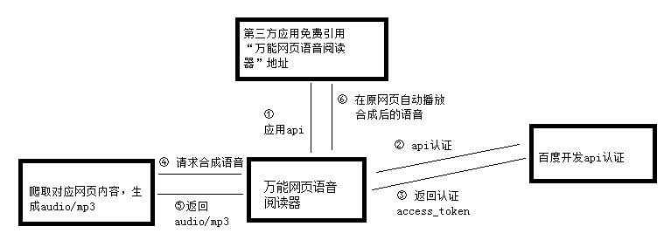

**主界面展示**：

测试页面：

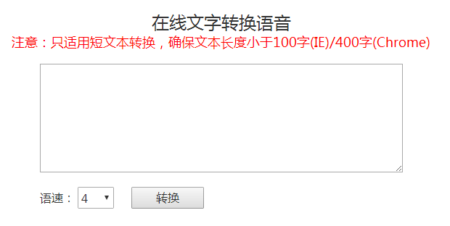

最终版本没有页面，只有引用js代码。类似百度统计的使用方法。

**调用百度云的功能介绍（代码片段截图）**：

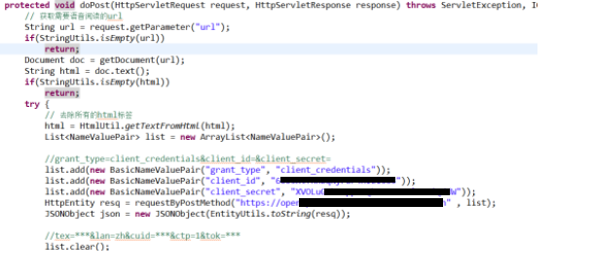

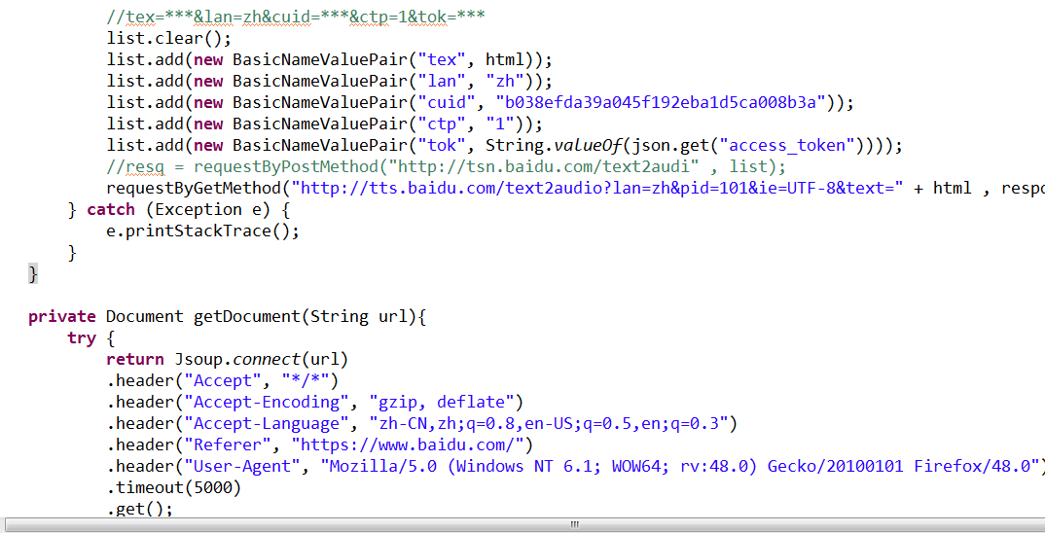

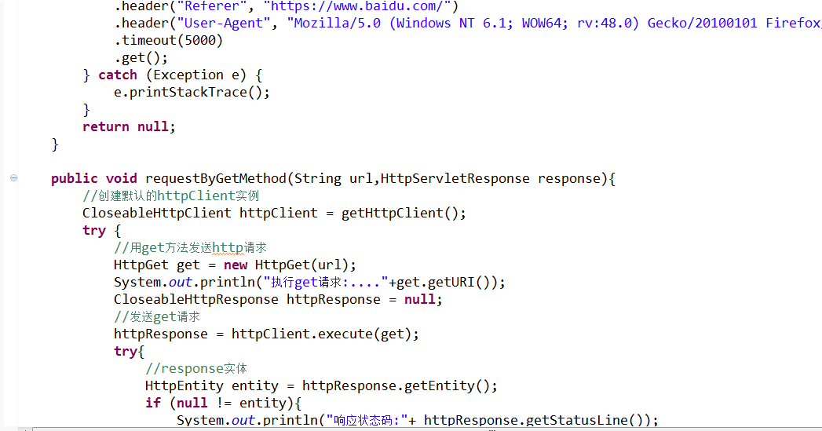

测试代码：

package net.codedq;

import java.io.IOException;

import java.io.UnsupportedEncodingException;

import java.util.ArrayList;

import java.util.List;

import org.apache.http.HttpEntity;

import org.apache.http.NameValuePair;

import org.apache.http.client.entity.UrlEncodedFormEntity;

import org.apache.http.client.methods.CloseableHttpResponse;

import org.apache.http.client.methods.HttpGet;

import org.apache.http.client.methods.HttpPost;

import org.apache.http.impl.client.CloseableHttpClient;

import org.apache.http.impl.client.HttpClients;

import org.apache.http.message.BasicNameValuePair;

import org.apache.http.util.EntityUtils;

import org.json.JSONObject;

public class Test {

public static void main(String[] args) {

List<NameValuePair> list = new ArrayList<NameValuePair>();

try {

//grant_type=client_credentials&client_id=&client_secret=

list.add(new BasicNameValuePair("grant_type", "client_credentials"));

list.add(new BasicNameValuePair("client_id", "test"));

list.add(new BasicNameValuePair("client_secret", "test"));

HttpEntity resq = requestByPostMethod("https://openapi.baidu.com/oauth/2.0/token" , list);

String result = EntityUtils.toString(resq);

System.out.println(result);

JSONObject json = new JSONObject(result);

//tex=***&lan=zh&cuid=***&ctp=1&tok=***

list.clear();

list.add(new BasicNameValuePair("tex", "上海"));

list.add(new BasicNameValuePair("lan", "zh"));

list.add(new BasicNameValuePair("cuid", "b038efda39a045f192eba1d5ca008b3a"));

list.add(new BasicNameValuePair("ctp", "1"));

list.add(new BasicNameValuePair("tok", String.valueOf(json.get("access_token"))));

resq = requestByPostMethod("http://tsn.baidu.com/text2audi" , list);

result = EntityUtils.toString(resq);

System.out.println(result);

System.out.println(resq.getContentType());

//requestByGetMethod("http://tsn.baidu.com/text2audi?tex=上海&lan=zh&cuid=test&ctp=1&tok="+String.valueOf(json.get("access_token")));

requestByGetMethod("http://tts.baidu.com/text2audio?lan=zh&pid=101&ie=UTF-8&text=上海");

} catch (Exception e) {

e.printStackTrace();

}

}

public static void requestByGetMethod(String url){

//创建默认的httpClient实例

CloseableHttpClient httpClient = getHttpClient();

try {

//用get方法发送http请求

HttpGet get = new HttpGet(url);

System.out.println("执行get请求:...."+get.getURI());

CloseableHttpResponse httpResponse = null;

//发送get请求

httpResponse = httpClient.execute(get);

try{

//response实体

HttpEntity entity = httpResponse.getEntity();

if (null != entity){

System.out.println("响应状态码:"+ httpResponse.getStatusLine());

System.out.println("-------------------------------------------------");

System.out.println(entity.getContentType());

System.out.println("-------------------------------------------------");

}

}

finally{

httpResponse.close();

}

} catch (Exception e) {

e.printStackTrace();

}

finally{

try{

closeHttpClient(httpClient);

} catch (IOException e){

e.printStackTrace();

}

}

}

/**

* POST方式发起http请求

*/

public static HttpEntity requestByPostMethod(String url,List<NameValuePair> list){

CloseableHttpClient httpClient = getHttpClient();

CloseableHttpResponse httpResponse = null;

try {

// 百度云语言合成url

HttpPost post = new HttpPost(url);

//url格式编码

UrlEncodedFormEntity uefEntity = new UrlEncodedFormEntity(list,"UTF-8");

post.setEntity(uefEntity);

//执行请求

httpResponse = httpClient.execute(post);

try{

return httpResponse.getEntity();

} finally{

httpResponse.close();

}

} catch(UnsupportedEncodingException e){

e.printStackTrace();

} catch (IOException e) {

e.printStackTrace();

} finally{

try{

closeHttpClient(httpClient);

} catch(Exception e){

e.printStackTrace();

}

}

return null;

}

private static CloseableHttpClient getHttpClient(){

return HttpClients.createDefault();

}

private static void closeHttpClient(CloseableHttpClient client) throws IOException{

if (client != null){

client.close();

}

}

}

**产品优势**：

1. 使用简单
2. 市场大
3. 朗读清晰
4. 背靠百度大腿

**市场前景/空间预测**：

前景可观，目前这样的功能市场还未大面积覆盖。市场空间大。